EXP.NO: 01 IMPLEMENTATION OF CAESAR CIPHER

AIM:
To implement the simple substitution technique named Caesar cipher using Python program.

ALGORITHM:
STEP-1: Read the plain text from the user. STEP-2: Read the key value from the user.
STEP-3: If the key is positive then encrypt the text by adding the key with each character in the plain text.
STEP-4: Else subtract the key from the plain text. STEP-5: Display the cipher text obtained above. PROGRAM:
text = input("Enter text: ")
key = int(input("Enter key: "))
encrypted = ""
for ch in text:
if ch.isalpha():
if ch.isupper():
encrypted += chr((ord(ch) - 65 + key) % 26 + 65)
else:
encrypted += chr((ord(ch) - 97 + key) % 26 + 97)
else:
encrypted += ch

print("Encrypted Text:", encrypted)

decrypted = ""
for ch in encrypted:
if ch.isalpha():
if ch.isupper():
decrypted += chr((ord(ch) - 65 - key) % 26 + 65)
else:
decrypted += chr((ord(ch) - 97 - key) % 26 + 97)
else:
decrypted += ch
print("Decrypted Text:", decrypted)

OUTPUT:
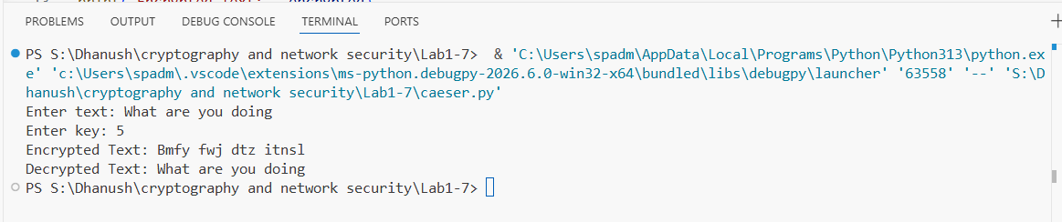

RESULT:
Thus the implementation of Caesar cipher had been executed successfully.

EXP.N0:2 IMPLEMENTATION OF PLAYFAIR CIPHER

AIM:
To write a python program to implement the Playfair Substitution technique.

ALGORITHM:
STEP-1: Read the plain text from the user. STEP-2: Read the keyword from the user.
STEP-3: Arrange the keyword without duplicates in a 5*5 matrix in the row order and fill the remaining cells with missed out letters in alphabetical order. Note that
„i‟ and „j‟ takes the same cell.

STEP-4: Group the plain text in pairs and match the corresponding corner letters by forming a rectangular grid.
STEP-5: Display the obtained cipher text.

PROGRAM:

key = "MONARCHY"
text = "HELLO"

matrix = [
['M','O','N','A','R'],
['C','H','Y','B','D'],
['E','F','G','I','K'],
['L','P','Q','S','T'],
['U','V','W','X','Z']
]

def find(ch):
if ch == 'J':
ch = 'I'
for i in range(5):
for j in range(5):
if matrix[i][j] == ch:
return i, j

cipher = ""

for i in range(0, len(text), 2):
a = text[i].upper()
b = text[i + 1].upper() if i + 1 < len(text) else 'X'

r1, c1 = find(a)
r2, c2 = find(b)

if r1 == r2:
cipher += matrix[r1][(c1 + 1) % 5]
cipher += matrix[r2][(c2 + 1) % 5]
elif c1 == c2:
cipher += matrix[(r1 + 1) % 5][c1]
cipher += matrix[(r2 + 1) % 5][c2]
else:
cipher += matrix[r1][c2]
cipher += matrix[r2][c1]

print("Cipher Text:", cipher)

OUTPUT:
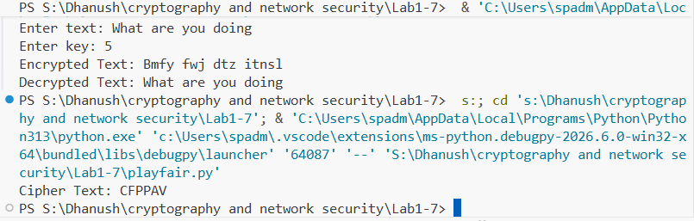

RESULT:
Thus the Playfair cipher substitution technique had been implemented successfully.

EX. NO: 3 IMPLEMENTATION OF HILL CIPHER

AIM:

To write a python program to implement the hill cipher substitution techniques.

ALGORITHM:
STEP-1: Read the plain text and key from the user. STEP-2: Split the plain text into groups of length three. STEP-3: Arrange the keyword in a 3*3 matrix.
STEP-4: Multiply the two matrices to obtain the cipher text of length three. STEP-5: Combine all these groups to get the complete cipher text.

PROGRAM:
key = [
[6, 24, 1],
[13, 16, 10],
[20, 17, 15]
]

text = input("Enter 3 letters: ").upper()

p = [ord(text[0]) - 65,
ord(text[1]) - 65,
ord(text[2]) - 65]

cipher = ""

for i in range(3):
value = 0
for j in range(3):
value += key[i][j] * p[j]

cipher += chr((value % 26) + 65)

print("Cipher Text:", cipher)

OUTPUT:

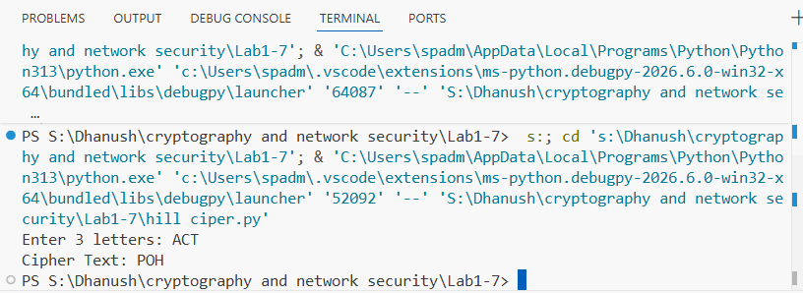

RESULT:
Thus the hill cipher substitution technique had been implemented successfully in C.

EX. NO: 4
IMPLEMETATION OF VIGENERE CIPHER

AIM:
To implement the Viegnere Cipher substitution technique using C program.

ALGORITHM:
STEP-1: Arrange the alphabets in row and column of a 26*26 matrix.
STEP-2: Circulate the alphabets in each row to position left such that the first letter is attached to last.
STEP-3: Repeat this process for all 26 rows and construct the final key matrix. STEP-4: The keyword and the plain text is read from the user.
STEP-5: The characters in the keyword are repeated sequentially so as to match with that of the plain text.
STEP-6: Pick the first letter of the plain text and that of the keyword as the row indices and column indices respectively.
STEP-7: The junction character where these two meet forms the cipher character. STEP-8: Repeat the above steps to generate the entire cipher text.

PROGRAM:

text = input("Enter Text: ").upper()

key = input("Enter Key: ").upper()

# Encryption

cipher = ""

for i in range(len(text)):

cipher += chr(((ord(text[i])-65) + (ord(key[i % len(key)])-65)) % 26 + 65)

print("Encrypted:", cipher)

# Decryption

plain = ""

for i in range(len(cipher)):

plain += chr(((ord(cipher[i])-65) - (ord(key[i % len(key)])-65)) % 26 + 65)

print("Decrypted:", plain)

OUTPUT:

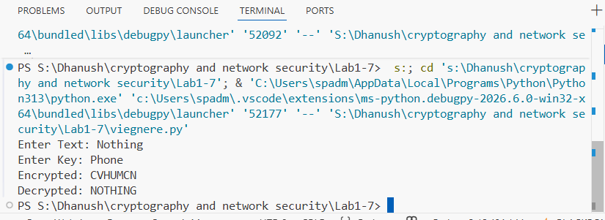

RESULT:
Thus the Viegnere Cipher substitution technique had been implemented successfully.

EX. NO: 5
IMPLEMENTATION OF RAIL FENCE – ROW & COLUMN TRANSFORMATION TECHNIQUE
AIM:
To write a python program to implement the rail fence transposition technique.

ALGORITHM:
STEP-1: Read the Plain text.
STEP-2: Arrange the plain text in row columnar matrix format.
STEP-3: Now read the keyword depending on the number of columns of the plain text.
STEP-4: Arrange the characters of the keyword in sorted order and the corresponding columns of the plain text.
STEP-5: Read the characters row wise or column wise in the former order to get the cipher text.

PROGRAM:
text = input("Enter Plain Text: ")
# Encryption
cipher = text[::2] + text[1::2]
print("Encrypted Text :", cipher)
# Decryption
n = len(text)
mid = (n + 1) // 2
first = cipher[:mid]
second = cipher[mid:]
plain = ""
for i in range(mid):
plain += first[i]
if i < len(second):
plain += second[i]
print("Decrypted Text :", plain)

OUTPUT:

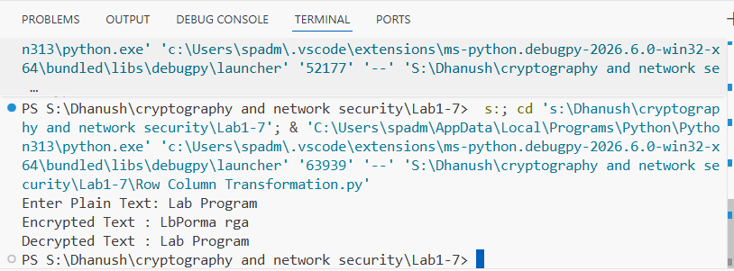

RESULT:
Thus the rail fence algorithm had been executed successfully

EX. NO: 6

AIM:

IMPLEMENTATION OF DES

To write a python program to implement Data Encryption Standard (DES) using C Language.

ALGORITHM:
STEP-1: Read the 64-bit plain text.
STEP-2: Split it into two 32-bit blocks and store it in two different arrays. STEP-3: Perform XOR operation between these two arrays.
STEP-4: The output obtained is stored as the second 32-bit sequence and the original second 32-bit sequence forms the first part.
STEP-5: Thus the encrypted 64-bit cipher text is obtained in this way. Repeat the same process for the remaining plain text characters.

PROGRAM:
from Crypto.Cipher import DES

key = b'12345678'

text = input("Enter Text: ")

while len(text) % 8 != 0:
text += " "

des = DES.new(key, DES.MODE_ECB)

encrypted = des.encrypt(text.encode())
print("Encrypted:", encrypted.hex().upper())

decrypted = des.decrypt(encrypted)
print("Decrypted:", decrypted.decode().strip())

OUTPUT:

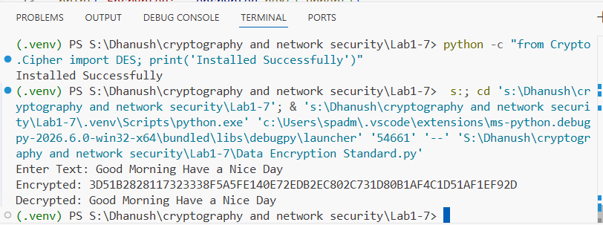

RESULT:
Thus the data encryption standard algorithm had been implemented successfully using Python language.

EX. NO: 7

AIM:

IMPLEMENTATION OF RSA

To write a python program to implement the RSA encryption algorithm.

ALGORITHM:
STEP-1: Select two co-prime numbers as p and q. STEP-2: Compute n as the product of p and q.
STEP-3: Compute (p-1)*(q-1) and store it in z.
STEP-4: Select a random prime number e that is less than that of z. STEP-5: Compute the private key, d as e * mod-1 (z).
STEP-6: The cipher text is computed as messagee * mod n.
STEP-7: Decryption is done as cipherdmod n.

PROGRAM:
p = 17
q = 11

n = p * q
e = 3
d = 107

msg = input("Enter Message: ")

# Encryption
cipher = []
for ch in msg:
cipher.append(pow(ord(ch), e, n))

print("Encrypted:", cipher)

# Decryption
plain = ""
for c in cipher:
plain += chr(pow(c, d, n))

print("Decrypted:", plain)

OUTPUT:

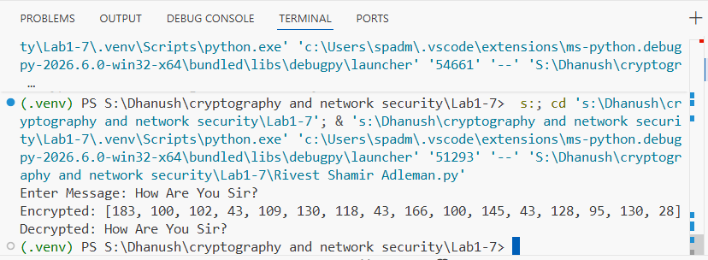

RESULT:
Thus the python program to implement RSA encryption technique had been implemented successfully.

